Referencias:

* <http://stackoverflow.com/questions/7414794/difference-between-contextannotation-config-vs-contextcomponent-scan>

Projecto 2 – Instruções

1. Criar o interface IMessageService

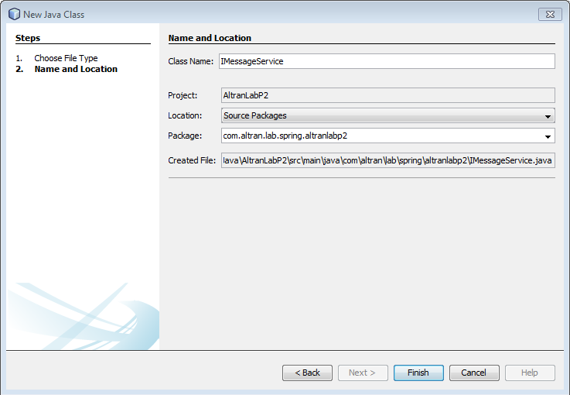

public interface IMessageService {

void sendMessage(String msg, String rec);

}

1. Criar o EmailService

public class EmailService implements IMessageService {

@Override

public void sendMessage(String msg, String rec) {

//logic to send email

System.out.println("Email sent to " + rec + " with Message = " + msg);

}

}

1. Criar o SMSService

public class SmsService implements IMessageService {

@Override

public void sendMessage(String msg, String rec) {

//logic to send SMS

System.out.println("SMS sent to " + rec + " with Message = " + msg);

}

}

1. Criar interface IConsumer

public interface IConsumer {

void processMessages(String msg, String rec);

}

1. Criar class MessageConsumer

public class MessageConsumer implements IConsumer {

private IMessageService messageService;

public MessageConsumer() { }

public MessageConsumer(IMessageService messageService) {

this.messageService = messageService;

}

public IMessageService getMessageService() {

return service;

}

public void setMessageService(IMessageService service) {

this.service = service;

}

@Override

public void processMessages(String msg, String rec){

//do some msg validation, manipulation logic etc

this.service.sendMessage(msg, rec);

}

}

1. Criar e alterar Spring Config

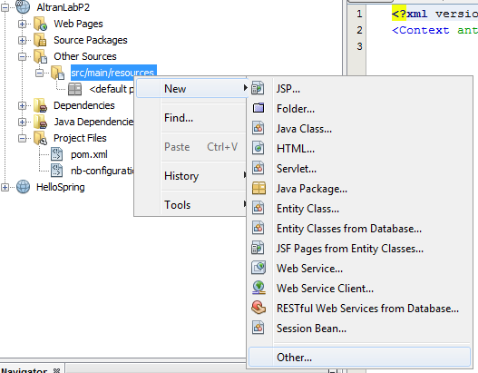

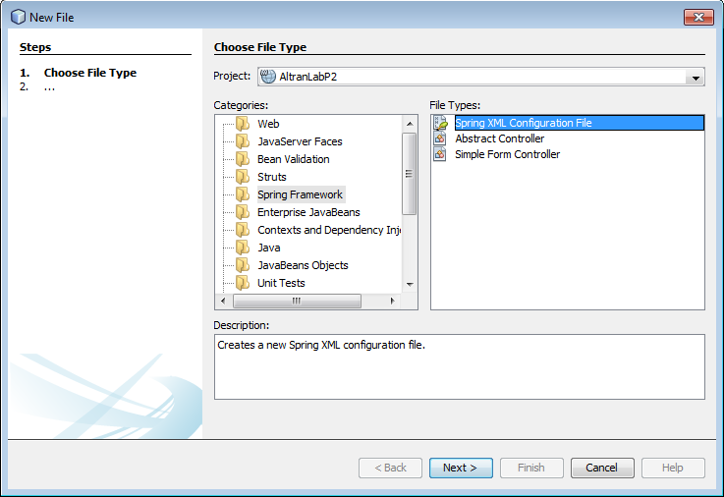

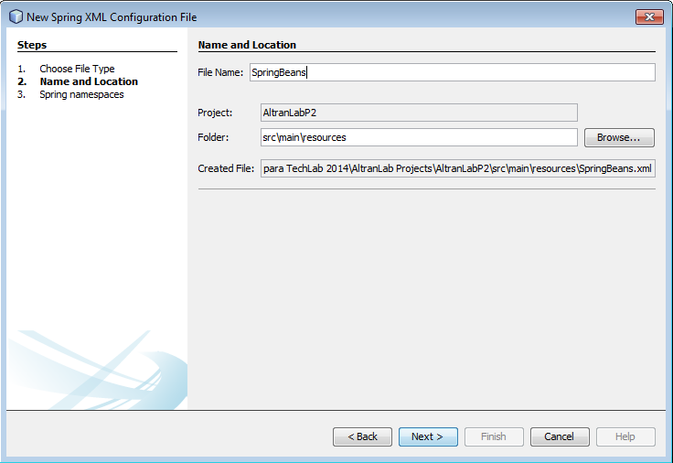

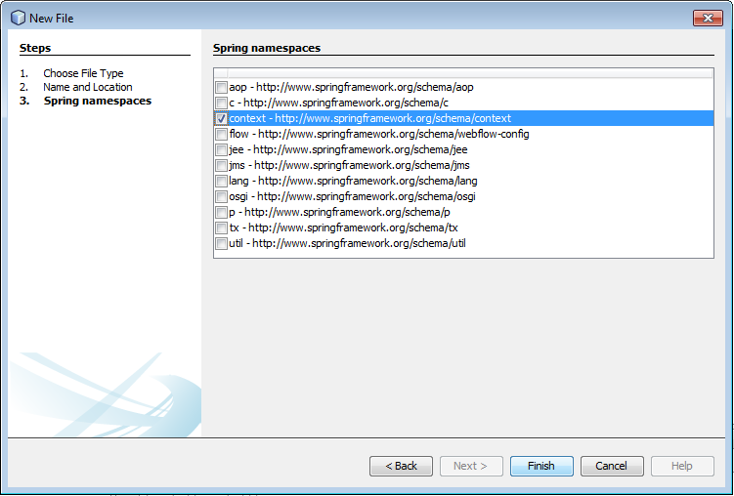

<!-- Bean do EmailService -->

<bean id="emailService" class="com.altran.lab.spring.altranlabp2.EmailService" />

<!-- Bean do SmsService -->

<bean id="smsService" class="com.altran.lab.spring.altranlabp2.SmsService" />

<!-- Injeção por construtor -->

<bean id="emailConsumer" class="com.altran.lab.spring.altranlabp2.MessageConsumer">

<property name="messageService" ref="emailService" />

</bean>

<!-- Injeção por setter -->

<bean id="smsConsumer" class="com.altran.lab.spring.altranlabp2.MessageConsumer">

<constructor-arg ref="smsService" />

</bean>

1. Criar App e correr

import org.springframework.context.annotation.AnnotationConfigApplicationContext;

import org.springframework.context.support.ClassPathXmlApplicationContext;

public class App

{

public static void main( String[] args )

{

/\* Xml \*/

ClassPathXmlApplicationContext classPathXmlContext = new ClassPathXmlApplicationContext("SpringBeans.xml");

IConsumer consumer1 = classPathXmlContext.getBean("emailConsumer", IConsumer.class);

IConsumer consumer2 = classPathXmlContext.getBean("smsConsumer", IConsumer.class);

consumer1.processMessages(" Hello 1! ", "recipient 1");

consumer2.processMessages(" Hello 2! ", "recipient 2");

}

}

1. Criar SpringBeansContainer

import org.springframework.context.annotation.Bean;

import org.springframework.context.annotation.Configuration;

@Configuration

public class SpringBeansContainer {

@Bean

public IConsumer emailConsumer() {

MessageConsumer consumer = new MessageConsumer();

consumer.setMessageService(emailService());

return consumer;

}

@Bean

public IConsumer smsConsumer() {

return new MessageConsumer(smsService());

}

@Bean

public IMessageService emailService() {

return new EmailService();

}

@Bean

public IMessageService smsService() {

return new SmsService();

}

}

1. Alterar App.java e correr

import org.springframework.context.annotation.AnnotationConfigApplicationContext;

import org.springframework.context.support.ClassPathXmlApplicationContext;

public class App

{

public static void main( String[] args )

{

/\* Xml \*/

ClassPathXmlApplicationContext classPathXmlContext = new ClassPathXmlApplicationContext("SpringBeans.xml");

/\* Annotations \*/

AnnotationConfigApplicationContext annotationConfigContext = new AnnotationConfigApplicationContext(SpringBeansContainer.class);

IConsumer consumer1 = classPathXmlContext.getBean("emailConsumer", IConsumer.class);

IConsumer consumer2 = classPathXmlContext.getBean("smsConsumer", IConsumer.class);

IConsumer consumer3 = annotationConfigContext.getBean("emailConsumer", IConsumer.class);

IConsumer consumer4 = annotationConfigContext.getBean("smsConsumer", IConsumer.class);

consumer1.processMessages(" Hello 1! ", "recipient 1");

consumer2.processMessages(" Hello 2! ", "recipient 2");

consumer3.processMessages(" Hello 3! ", "recipient 3");

consumer4.processMessages(" Hello 4! ", "recipient 4");

}

}